**LITERATURE REVIEW PROJECT: DEVICE-TO-DEVICE (D2D) COMMUNICATIONS**

SAYAN KOLEY, STEVEN STAROWICZ, CHITVAN CHAUHAN, KOUSHANI CHAKRABARTY

GROUP 2 – REPORT SUBMISSION

ABSTRACT:

***In this modernized world of today, with the advent of Artificial intelligence and automation cooperation and coherence between devices has a great potential to change the digital world. Emerging D2D networks has a great potential to facilitate the robust development of peer-to-peer network. This will further lead the D2D communication framework to make a part of Internet of things [IOT]. Device-to-device (D2D) communication encompasses the transmission of wireless signals between devices without the explicit inclusion of a Base Station (BS) or an evolved Node B (e-NB). Device-to-device (D2D) communication is expected to play a significant role in upcoming cellular networks as it promises ultra-low latency or communication among users. D2D approach is such a novel approach that it works without the essential control of the centralized controller which makes wireless networks more energy efficient and spectrum friendly with the presence of considerable amount of network traffic. The performance of then D2D wireless communication depends a much on the operational limits of the devices and on the limits of the resources that the network comprises of. Several issues need to be addressed in order to further improve the performance of D2D communication technology. Some of the factors that the D2D technology’s performance is dependent upon are the resources utilized, routing techniques, bandwidth utilized, interference avoidance management, faster and efficient device discovery, and time-constrained device handover and mobility concerns. So, this paper broadly highlights few of the factors that the performance of the D2D wireless communication is dependent upon.***

***Keywords: - “D2D (Device to Device Communication), IOT (Internet of Things), BS (Base Station), Evolved Node B(e-NB),DUE(D2D User Equipment),CUE(D2D communication cellular user equipment),LTE(Long Term Evolution),5G(Fifth Generation),V2V(Vehicle-to-Vehicle),V2X(Vehicle to Environment),V2P(Vehicle to Pedestrian).CU(Cellular User),UAV(Unmanned Aerial Vehicle), Ultra-Reliable and Low Latency Communications (URLLC),Dedicated Short Range Communication(DSRC).”***

1. INTRODUCTION

Due to the convenience brought to people’s lives by wireless products, the beginning of the 21st century has witnessed a great increase of wireless devices and applications. With the advent of the fifth generation of wireless networks (5G) shows great promise, one potential area of communication that has undergone a lot of research over the past couple of years is device-to-device (D2D) communication. D2D communication encompasses the transmission of wireless signals between devices without the explicit inclusion of a Base Station (BS) or an evolved Node B (e-NB). While a control node may still assign spectral bands allocated for D2D transmission in a cell, the connection establishment and data transmission packets are handled entirely by the devices [2b]. With this starting point in mind, D2D schemes have evolved into schemes utilizing in-band or out-band implementation, overlay versus underlay spectral division, and operation in the unlicensed or license frequency bands.

As the type of files transmitted through the internet have changed from basic textual and database information to streaming audio, video, and live teleconferencing, throughput and connection speeds have increased to accommodate these new digital appetites. Questions about the feasibility of millimeter wave (mm-Wave) frequency transmissions have become common place, but a practical division appears at roughly the 6GHz line. This division is at the upper limit of Wi-Fi connectivity, as is the point where connections move from being Long Term Evolution (LTE) and cellular-type connections to purely sub-mm-Wave connections with greatly reduced ranges. New research initiatives into mm-Wave transmission characteristics and solutions seem to be focused on the fundamental physics of what is possible, and may require a total re-imagination of what connectivity and service cells look like. With the complexity of fundamental research and the significant additional learning required to understand some of its basic implementation pathways, we find that novel D2D communication solutions in the sub-mm-Wave range highlight the technical prowess of current engineers while addressing complications and difficulties that are present in existing communication systems.

1. PROBLEM STATEMENT

As a result of our curiosity regarding the use of optimized sub-mm-Wave D2D communications in emerging fields, this paper comprises a literature review of interference mitigation for single as well as multiple pairs of D2D devices. This area of research does not suffer from some of the problems that mm-Wave communication does, as detailed in [3d], which include poor range, coverage holes, complicated peer discovery, and a close operating proximity to fundamental physical limits. Instead, the sub-mm-Wave D2D transmission range focuses on a variety of measurable and (largely) controllable elements such as interference management, spectral division, device discovery, and handover and mobility considerations. Two emergent use cases that highlight the recent work within the sub-mm-Wave transmission space are the injection of a UAV as a relay assist node in a D2D multi-hop connection, and the development of a vehicle-to-environment (V2X) network space. The sum total of the evaluation of these discrete elements comprises a way to meet Quality of Service (QoS) metrics to the D2D user, without affecting connections to the more traditional cellular networks.

1. METHODOLOGY

To begin, we found that the best way to avoid interference was through a careful allocation of the spectral bands for D2D and cellular transmission. By use of a controlled allocation of spectrum, a great many interference concerns may be avoided, with a commensurate loss in service due to base station processing overhead. With a non-mediated spectral use case (I.e., cellular users operate in their designated frequencies and D2D implementation happens freely in unlicensed bands), we find that the removal of processing overhead a the base station may be offset by interference it cannot control. Factoring in opportunistic interference avoidance algorithms, and management of device discovery, we find that there is no silver bullet or magic bean regarding communication protocols or methodology. We instead find that the requirements of the unique network will define the types and styles of control elements implemented. What follows in this section is an exposition of the main methodologies that contribute to a minimization of interference in the D2D space when co-existing with other cellular users, various other communication infrastructure and transmission nodes, and similarly serviced D2D users.

3.1 SPECTRAL ALLOCATION AND SYSTEM DESIGN

Given a hexagonal multi-cell LTE-A network, as shown in **figure XX**, this cell comprises N users such that n **that exists in** N := 1, 2, 3.....N

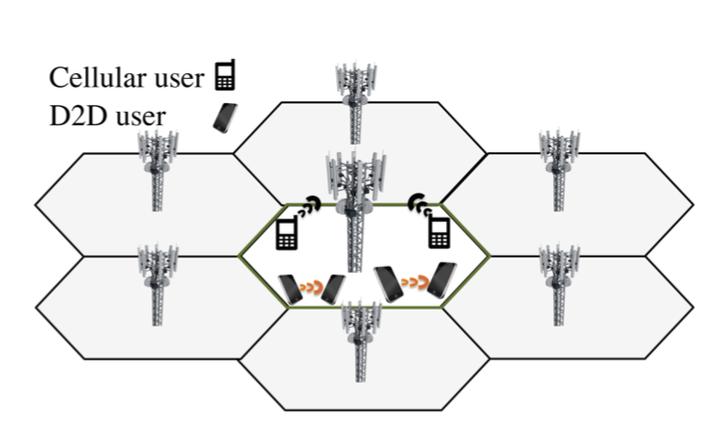

Downlink and uplink channels exist separately and each has fixed bandwidth. As evidenced **in figure XX**, inband D2D uses the uplink cellular spectrum. It is possible for users to communicate both with users inside the cell as well as outside. For close-range communication, D2D communication can be used. Each connection between two users is referred to as (n,m) **that exists in** N. The base station is assumed to be N + 1. With the above in place, this is how the mode selection is designed:

|  |  |
| --- | --- |
| mode0 | Cellular |
| mode1 | Inband underlay D2D |
| mode2 | Inband overlay D2D |
| mode3 | Overlay D2D |

As mentioned above, the base station is responsible for mode selection and scheduling. Scheduling decisions are made on a per frame basis. Each frame is 10ms long and consists of 10 subframes. Each subframe is assigned to a cellular user by default, and no restrictions are imposed on the number of concurrent D2D transmissions. This method is able to reduce interference between cellular users but not between an inband underlay user and a cellular user, or between two inband underlay users. Since a fixed bandwidth is assigned to overlay users the only interference an overlay user can get is from another overlay user. When unused, the overlay spectrum can be utilized by lending it to cellular users. Outband users restrict their communication over the WiFi channel.

Since mode selection and scheduling require decision making schemes with different time scale resolutions, Floating Point D2D network attempts to decouple the scheduling and the mode selection process. In a real-world scenario, D2D connections would last for a few frames, therefore, assigning them on a frame by frame basis would require significant signaling overhead. Short range of D2D communications imply that the channel quality of D2D links are much less time variant when compared to long range cellular links, and the decoupling method also simplifies the integration of the D2D communications with the cellular one. Even decoupled, scheduling and mode selection are still very much dependent on each other. Scheduling is affected by interference, which is unknown by the transmitted prior to mode selection. Yet, mode selection depends on the proportion of cellular users to D2D users. This is why the base station is responsible for scheduling as well as mode selection, carried out in the order of:

* **By Mode Selection:** Each user is assigned a mode (0-3) and the modes are reassigned at mode intervals of T seconds. To reduce complexity, the modes are assigned by assuming the worst-case interference scenario.
* **Scheduling:** The eNB then assigns each user a schedule along with a modulation and coding scheme.

Both mode selection and Scheduling require Channel state data (CSI). Besides, for D2D communication, the eNB also requires user to user CSI , apart from user to eNB CSI. Acquiring this can be challenging and the next stage of research in this area would be to acquire this data without adding significant amount of signaling overhead. A possible method is to include an interference matrix ***I (n,m)*** in the CSI header, which includes the unique ID’s of the devices interfering in the communication between users (n,m).

3.2 METHODS OF AVOIDING INTERFERENCE

The presence of interference in D2D communication can lead in performance degradation in the wireless networks. There are multiple interference mitigations schemes that are provided in this paper. These schemes can if implemented have the capability to provide Quality of Service (QoS) and a reliable communication environment. [1b]

3.2.1 POWER CONTROL TECHNIQUE [2B]

It is one of the most common interference mitigation techniques. Figure. 1b shows the schematic representation of the Power Control Strategy. Power control scheme depends on the mutual distance between the D2D pairs and distance between D2D pairs and the Cellular Users (CUE). When the eNB or CUE are close enough to the D2D pair and the distance between the D2D pair is large, it decreases the transmitted power of D2D users which result in very low probability of D2D communication or even prevent D2D communication at all between the D2D pairs.

Therefore, Power Control Technique can mitigate interference only when the D2D pairs are close enough to each other and at a sufficient distance from EnB or CUE.

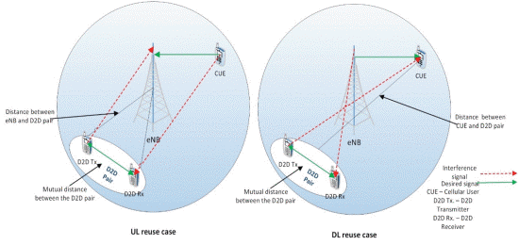

Fig. 1b D2D Power Control Model[2b]

3.2.2 RADIO RESOURCE ALLOCATION TECHNIQUE [2B]

This method utilizes various resource allocation algorithms. The main is to assign a radio resource to a group of D2D pairs successfully. By using the location based resource allocation method to mitigate interference between D2D and CU users was studied. This technique ensures that the users in accessible regions can share the same radio resources in the reusable regions. A drawback of this technique is that underutilization of radio resources results in limiting the scheduling alternatives of the EnB.

3.2.3 SPECTRUM SPLITTING TECHNIQUE [2B]

This technique adopts the Time Division Multiplexing Technology(TDM) to separate cellular and D2D transmission. The major drawback is TDM leads to inefficient utilization of the available spectrum.

3.2.4 MULTIPLE-INPUT MULTIPLE-OUTPUT (MIMO) TECHNIQUE [2B]

This technique is widely used to increase the overall system performance of the network. MIMO uses the methods such as beamforming, interference cancelling technique to mitigate interference between cellular links and D2D links.

Beamforming uses multiple transmit and receive antenna element to receive directional antenna beam pattern. The generated beam gets steered to the recipient while canceling out undesirable interference towards the users. It results in increased SINR and reduced wastage of the transmitted power. As seen in Figure. 2b there is EnB beamforming on the cellular downlink to mitigate the effect of interference and avoiding the generation of cross-tier interference to D2D receiver.

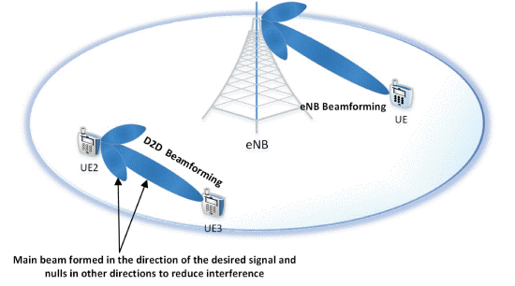

3.2.5 NON-ORTHOGONAL RESOURCE SHARING SCHEME [3B]

It uses the uplink fractional Power Control Method. The technique aims at high throughput and less power consumption, the LTE-a uplink scenario is considered in which cellular users and D2D users are active at the same time. The performance analysis shows that the proposed scheme can achieve higher throughput the resource management scheme. As the multicast D2D group radius increases with the increase in power consumption, channel gain of the users decreases

with the increase in group radius.

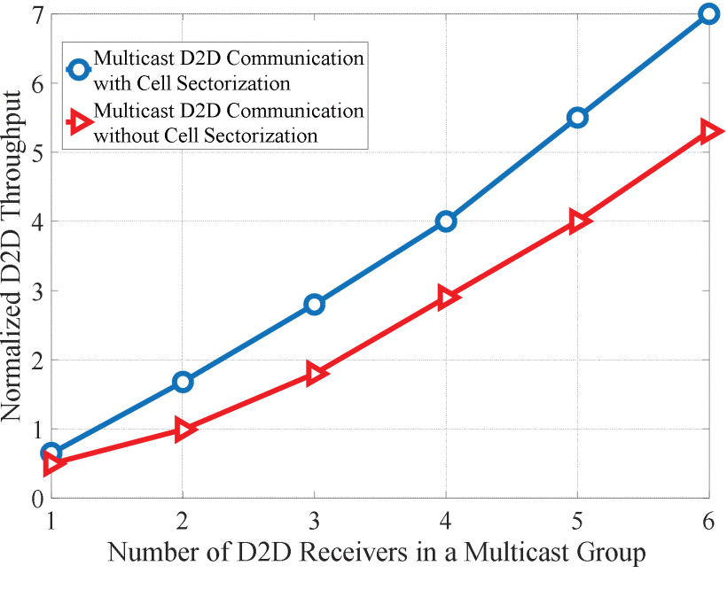

3.2.6 P-OPPORTUNISTIC CHANNEL ACCESS SCHEME (P-OCAS) [4B]

It minimizes interference from roadside units(RSU). Vehicular networks can access internet if they are connected to the RSU via V2I communication. The problem occurs when RSU cannot sense the V2V communication during the downlink period when V2V is in communication with the RSU.

P-OCAS is dynamically able to adjust the channel access probability with respect to access load of network at any point in time. P-OCAS was compared to p-random channel and p-persistent channel and it was observed to have a 36.8 percent increase in the overall throughput off the p-OCAS channel.

3.2.7 ORTHOGONAL FREQUENCY DIVISION MULTIPLEXING (OFDM) WITH VIRTUAL CARRIERS [5B]

The Orthogonal Frequency Division Multiplexing Systems are used in the new generation communications. It provides immunity to the fading channel caused by the Multipath phenomenon. OFDM transforms a frequency selective fading channel into a flat fading channel with a certain coherence bandwidth, by using multiple frequency subcarriers. The OFDM system deliberately sacrifices the spectral efficiency of the system by increasing redundancy or by lowering the rates in Forward Error Correction(FEC) by employing Virtual Carriers(VC). VCs are applied to as data guards to combat ICI within the OFDM symbol as shown in fig. 5b. Mapping Block forms the OFDM symbol with a vector of zeroes ZVC being assigned.

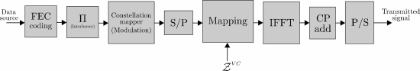

3.3 EFFICIENT DEVICE DISCOVERY

Since the beginning of time of modernization of the human race, the human race has felt the requirement of better and faster communication for the secure exchange of data or information. The exchange of data has always been a crucial deciding factor for many scenarios in the life of the mankind. With the advent of the age of automation and artificial intelligence; there has been a growing requirement of devices to communicate with each other. This led to formation of Internet of the people and further the internet of things. Device to device communication is a vital part of such wireless communications. There has been always been an inherent problems with Vehicle to Vehicle(V2V), V2I(Vehicle to Infrastructure) communication.V2V communication using wireless Local area Network has many problems like range because the distance between the vehicles and vehicle or vehicles and infrastructure or pedestrians is always going to change all the time[1].Further, the bandwidth is going to become saturated as the requirement of setting up multiple connections between V2V or V2I needed to be set up[7].There is also increase in latency in such communication systems[5].Moreover, as the latency of such a vital system of communication increases, the infrastructure can’t be used for autonomous systems as it becomes unreliable[6]. The latency may be one of the problems that these medium of communication may be facing. But there can be other secondary issues that may be faced in this case because of this latency such as the autonomous and cooperative algorithms may become inoperative if the delays are more than a certain threshold leading to further malfunctioning of the smart system [8]. But among the problems that have been mentioned so far, the most important one among them is the requirement of faster device discovery [1].

In the recent years V2P communications using Wi-Fi-Direct has been proposed but still they did not refer to the problem of device discovery [9,10,11]. One of the methods devised for faster device discovery in case of V2V or V2P communications is Collective Scanning and Collective scanning + Extensive Receiving. In the method of Collective Scanning, a vehicle that is operating in one channel receives responses from all kinds of pedestrians which operate in available channels as shown in Fig.1.The waiting time for responses is reduced by improving the scanning time. “This method basically involves generation of a probe request by a vehicle and basically consists of two new fields known as response channel field and response offset time field. Response channel field involves the vehicle’s channel that are receiving responses. On the other hand, the other filed that is the response time offset signifies the offset time within which a vehicle may receive responses. Whenever a probe request is received by pedestrian, the probe response is received back from the pedestrian on the Response channel on the Response offset time. The absolute value for Response offset time shall be about 7520 microsecond(μs). Response Offset Time is described by: Response Offset Time = (Chnum − 1) × Dpreq (1). In the above equation (1) the Chnum denotes the number of available channels and Dpreq denotes an interval of sending Probe Request on a channel. Dpreq is describes as below by the following equation below: -

Dpreq =Tch + DIFS + BackOff + Tsys + Tp + Tpreq (2) where Tch denotes the switching time of a channel, Tsys signifies the internal system process time, Tp basically signifies the sending time of a preamble, and Tpreq signifies the sending time of Probe Response. Tch is set as 250 μs . The switching time of a channel depends on capacity and implementation of NIC (Network Interface Card). DIFS, BackOff time are described by:

DIFS = aSIFSTime + 2 × a Slot Time (3) Back Off = CW× aSlotTime (4) mw here a SIFSTime = 10 μs and a Slot Time = 9 μs. The reason is that this proposal method uses IEEE 802.11n.CW (Contention Window) is defined as a random value between CWmax= 255 and CWmin = 15. CW is set as 15 since CW of at first time BackOff is 15. Tsys is defined as 300 μs. The reason is that a vehicle needs to wait until the vehicle completes sending a frame when the vehicle switches a channel. The internal system time requires 300 μs in NS-3”[1].

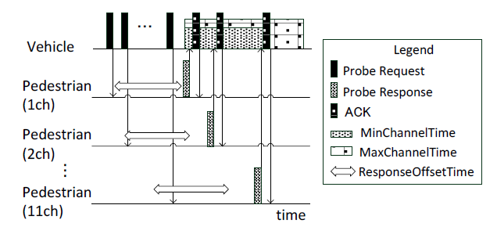

The other method followed is a modified form of Collective scanning that is Collective scanning+extensive receiving. It’s an extension method of Collective Scanning. As soon as the min.channeltime is elapsed, the vehicle will confirm the number of received responses at some intervals which are regular within the ExtensionChannelTime to determine the completion of receiving of responses from all such pedestrians while the vehicle may have been in a waiting state while scanning as shown in Fig. 2.This method in turn is an improvement of the scanning time and the detection leakage of pedestrians is prevented by the vehicle that extends waiting of responses depending on the number of responses from pedestrians.[1]

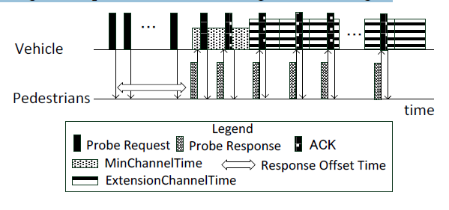

In another of the works in this literature they proposed a scheme which aims to reduce participation delay in D2D discovery and to minimize the performance degradation in terms of guaranteed distance between device equipment's which share the same resource. In the work they proposed a system, “in which all D2D User Equipment’s (D-UEs) participate in D2D discovery procedure as long as they are interested in any kind of D2D communication. They do so by the process of receiving beacons and concurrently sending a beacon periodically, keeping in track of the all nearby D-UEs in its proximity as shown in Fig. 3. Energy crisis is a concern in this case as the devices have to participate in device discovery all the time. This is taken care of by adjusting the period of discovery procedure which is denoted as Tperiod and is typically taken as 10secs.Further the duration of device discovery participation denoted by Tdiscovery by each device is very less in a period usually few microseconds. To be further specific, in every period; every D-UE in the system becomes active and conducts some discovery related actions (say, beacon transmission and reception) using the D2D discovery resource. After performing this task of discovery they again become inactive until there is considerable network traffic. In Fig.3, there are few of the transmission exchange scenarios shown for the D-UEs.There may be multiple other scenarios. So it is not always guaranteed that D-UE A’ beacon will be successfully received at the D-UE B’s side even though D-UE A Received D-UE B’s beacon successfully”. Three resource selection algorithms are basically used. They are basically Random Selection, Greedy Selection and Hybrid selection procedures. In fig 4. The resources allocation for device discovery has been shown. [2]

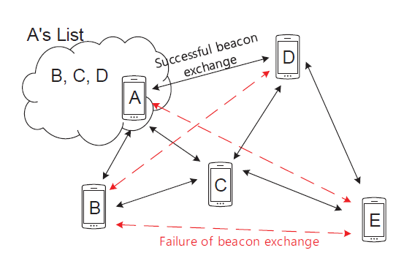

Fig.

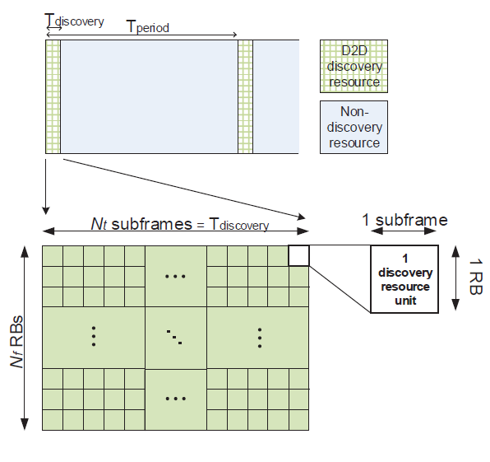

Fig.

One of the other methods that has been described in this literature is the “D2D discovery maximization (D2D-DM) iterative algorithm, which provides the capability to switch the discovery mode from half-duplex to in-band full-duplex, when signal-to-interference-noise ratio falls below a predefined threshold. The simplified system model used in this scheme as a single cell with a BS at the center and with κ users is shown as an example in Fig. 5. Uniformly distributed κ users in each cell is considered, where N users are PS(Public safety) users and M users are non-PS(non public safety) users. Initially, it is assumed that all the users are connected in HD(Half duplex) mode, but later on only N PS users can switch their communication to IB-FD(In-band-Full duplex) mode in order to satisfy their SINR threshold requirements. In HD mode, the user transmitting the beacon cannot listen to the beacon, whereas in IB-FD mode the user can transmit and receive beacon during the same time which in turn will increase the RBs(Resource Blocks) utilization efficiency.So, the PS users can discover more number of users within less time during emergency situations in IB-FD mode. The SINR ratio is basically used to find out number of discovered users”. [3]

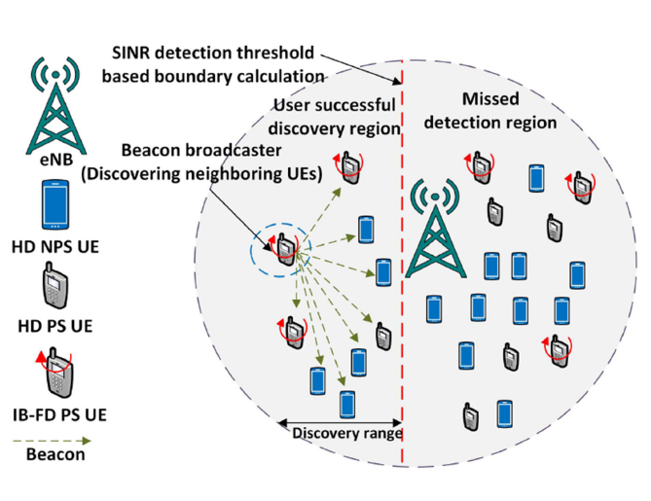

One of the other methods devised is by using Sphere Decoder Algorithm. This approach is” a distinctive approach for faster device discovery in an in-band cellular network and exploits the concept of device’s power and improves the D2D communication by improving the device discovery speed. In this method the group of devices basically are taken to form a lattice structure, and they are placed on the coverage area. Then a hypersphere is constructed which is totally based on the discoverer device’s power knowledge which helps in faster and accurate device discovery in a lattice structure. The algorithms like the (SDL) algorithm or Sphere decoder algorithm is further applied for quick and precise discovery in the lattice structure. In Fig.6 ,a system model for device discovery where R is the radius of a sphere made by the discoverer device is shown. In this scheme only synchronous D2D device discovery was considered say for an example, when all D2D devices are synchronized in time and coverage area reference can be acquired from the base station downlink transmission. This method uses significantly less energy as compared to asynchronous[4].

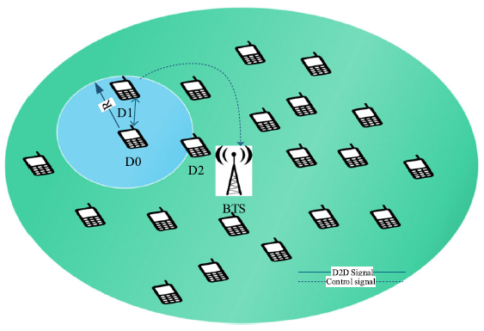

3.4 PRACTICAL USE CASES: UAV AND V2X

3.4.1 UAV RELAY NODES: CONSTRAINED BY POWER CONSIDERATIONS

In the event of a natural disaster that prevents eNB entities from transmitting to nearby devices, a possible connection opportunity involves the use of an unmanned aerial vehicle (UAV) as a relay node [2d]. One possible configuration of this idea is shown in Figure 1, with our emphasis on the pathway between two D2D clusters (shown in blue). Use of the UAV in this implementation replaces cellular connectivity initial provided by the damaged or inoperable base stations, shown in light green. One particular observation we make from the example shown in Figure 1 is that the devices within range of the UAV are all at the edges of its broadcasting range. The UAV transmissions must be of sufficient power to reach all source nodes (cellular devices with D2D capabilities) in the blue circle enclosed in a dotted line, meaning that addressing interference concerns are very important to the successful implementation of this configuration. Additionally, flight endurance for a UAV is limited by battery capacity and payload considerations, leading to requirements for power efficiency and a reduction in processing overhead to provide longer link up-time.

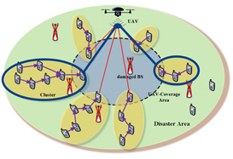

*Figure 1: Connection between two D2D clusters via a UAV relay node [2d].*

Our search for solutions to these technical questions lead to examining power allocation via low-complexity power control algorithm in [9d] to address the longevity of airborne platforms. Studies like [2d] attempt to ensure Quality of Service (QoS) levels primarily by reducing Signal-to-Interference-plus-Noise Ratio (SINR) via the use of precoding vectors for connections between two D2D clusters. In another study focused on IoT devices [8d], one possible way to increase throughput in a node while limiting interference is to use semisequential relays between D2D devices. This particular solution relies on nearby D2D devices with pathways to the base station to transmit portions of the source D2D file, distributed by both time and channel. The example provided in [8d] reduces transmission time by sending a file in distributed fashion over faster neighboring D2D connections when compared to transmission over a direct connection from source device to the base station. The study [7d] proposes reduction of interference via use of an underlay configuration instead of an overlay configuration, where the base node (or in our example, the UAV) sees less interference impact based upon lower signal strengths and physical separation of the various transmitting D2D nodes. Finally, [4d] considers intra-inter-cell D2D communications, where D2D users may connect to each other if in range, making use of single- or multi-hop connections with shorter physical pathways than through traditional cellular communications.

3.4.2 V2X ENVIRONMENT: CONSTRAINED BY HANDOVER AND MOBILITY CONSIDERATIONS

In contrast to the requirements of the a UAV relay node implementation, the use of D2D communications in a Vehicle-to-Environment (V2X) implementation suffers most acutely from issues associated with vehicle speed while moving through the network cell or cluster. Using the benchmark of vehicles traveling at highway speeds in the state of New York, we find that they proceed at approximately sixty-five miles per hour (65 MPH). Our back-of-the-envelope calculation in (1) reveals that a vehicle traveling at this speed moves roughly one inch per millisecond.

65 miles1 hour∗5280 feet1 mile∗12 inches1 foot∗1 hour60 mintes∗1 minute60 seconds∗1 second1000 milliseconds=1.1 inches1 ms

(1)

Totaling this distance for an entire second yields one-thousand inches per second, or just more than eight-three feet per second. During our background research, we found that the maximum range for 60GHz V2V transmissions are also roughly this distance, ranging from five to ten meters (5-10 m) in [10d]. Since the required value for Ultra-Reliable and Low Latency Communications (URLLC) included in the International Telecommunication Union’s report ITR-U M.2410-0 is also one millisecond (1 ms), we fully appreciate that time is of the essence for making fully autonomous vehicles work in the V2V or V2X space. In recognizing that mmWave transmissions have a broadcast range of the same magnitude as the distance a car on the highway travels in one second, we chose to focus our research on sub-mmWave transmissions. This choice allowed us to tackle basic questions concerning handover, mobility, discovery, and interference for vehicles communicating at highway speeds without requiring us to learn entirely new ways of arranging and managing network clusters.

Looking at the solutions for sub-mmWave transmissions, [5d] proposes the practical use of a Vehicular Ad-Hoc Network (VANET), incorporates cellular connectivity to handle vehicle-to-infrastructure (V2I) connections with the goal of bridging the gaps during handover of V2V transmissions or Dedicated Short Range Communications (DSRC). Source [6d] conducts testing regarding link activation times during handoff, and confirms the suggestion of [5d] that LTE may be used for navigation and waypoints, while V2V may be used for in-pod emergency or priority communications. Moving to a consideration of how spectral bandwidth is divided between cellular and V2V users, [1d] finds that such allocation may produce collisions or undesired interference between the two which requires an optimum power allocation algorithm for each spectral assignment block. In this block, power constraints are calculated for and addressed first, with assignment of spectral blocks conducted after this initial evaluation. Finally, we see in [3d] that the authors report ways to decrease interference by increasing spectral efficiency within a cluster, or attempting to offload processing applications to the network edge.

1. DATA AND SIMULATION

4.1 RESULTS FOR D2D DISCOVERY

Simulation parameters FROM [2] are summarized in Table 1. “The locations of D-UEs are distributed based on Spatial Poisson Point Process (SPPP) model. In practice, there must be more than two D-UEs which share the same DRU because the area, that a cellular system supports, is very large. Therefore, the distance among D2D user equipments(D-UEs) which share the same DRU(Discovery Research Unit) is the exact performance indicator. In Fig. 7, the average minimum distance is shown according to the number of D-UEs per cell. In the study, each DUE determines the minimum distance by calculating distances to D-UEs which share the same DRU and by selecting the lowest one. So as the number of D-UEs per cell increases, the average minimum distance decreases because more D-UEs have to share the same resource. [2]

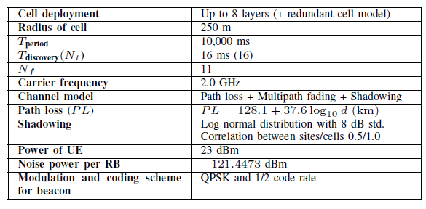

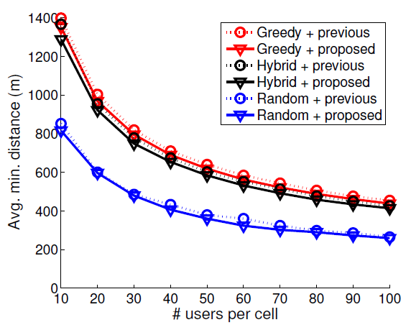

4.2 RESULTS FOR UAV RELAY NODE

When configured as in [2d], the study [7d] determined that underlay is the most economical utilization, providing the best performance even when considering interference from other D2D users. This is especially important in UAV deployment as a relay node, where hardware capabilities may prevent active direction of spectral allocation for users beyond its range. Here, we present Figure 2 as a visual representation of the expected delay time (E[T]) versus the arrival rate (λc) of packets in underlay versus overlay implementations, as gathered by [7d]. Note that the lower expected delays at higher arrival rates prove a better performance of the underlay apportionment of the spectrum, when compared with static and dynamic overlay implementations. These graphs show a general faster response rate of the underlay implementation during heavier traffic, and merely comparable response in lighter use cases. It is important to emphasize again that although we advocate underlay implementation for UAV relay node situations based on our research, the data shown in Figure 2 are representative of D2D users with a traditional cellular infrastructure, something not necessary correlative on a one-to-one basis with our UAV implementation as show in Figure 1.

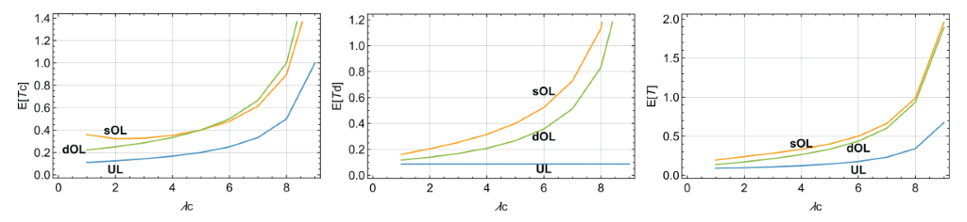

*Figure 2: Delay versus arrival rate for static overlay (sOL), dynamic overlay (dOL), and underlay (UL) implementations.*

Further, we show that the when focused on optimal transmission power, the use of the precoding vector proposed in [2d] provides the performance shown in Figure 3, with a minimum of required transmission power. The two higher lines in green and light blue indicate values for a transmission distance of fifty and one-hundred meters, respectively, with random precoding prior to transmission. The bottom lines in red and dark blue indicate results for a transmission distance of fifty and one-hundred meters, respectively, with an optimal precoding scheme. At roughly four milliWatts (4mW) of power, Figure 3 shows a total connectivity above 70%, as compared with the random precoding which bears an outage probability of 70%.

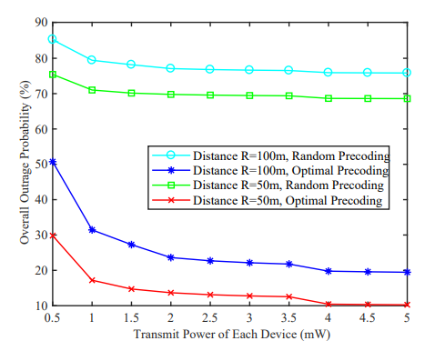

*Figure 3: Outage probability versus transmitter power for random and precoded transmissions.*

1. CONCLUSION AND FUTURE MOTIVATIONS

The promising modernized technology of D2D wireless communication tries to achieve the maximum point for the throughput of the system through enhanced spectrum efficiency. But reusing a new part of the spectrum can be harmful. To speak succinctly, it will lead to the advent of interference among the network clients such as the primary and secondary users such as the D2D users. In conglomeration to the above, there can be other kinds of mutual interference among multiple D2D pairs who share the same resources. This undesirable interference degrades the overall network performances which must be tackled. The various interference mitigation schemes that has been discussed in this paper such as power-control, efficient resource allocation, multi-antenna beamforming etc. are able to remove some of the interferences but not all. The power control scheme is not enough to handle the mutual interference between D2D communication and cellular Network. The licensed spectrum stays underutilized when the various resource allocation strategies proposed are implemented for removing interference problem. To further conclude the multi-antenna beamforming schemes mentioned are used mainly focused on suppressing downlink interference from e-NB to D2D receivers while ignoring the problem of uplink precoding for interference mitigation from D2D communication to cellular users. So, this area needs to be further studied in order to find out the way to remove cross–tier and co–tier interference during uplink resource sharing. There can be increased interference among cellular users if asynchronous communication scheme. However, by employing a waveform with improved spectral localization compared to OFDM, such as FBMC (Filter bank-multicarrier)/OQAM (Optical Communication System), DUEs (D2D User Equipements) can avail of the benefits of asynchronous communication without suffering a performance loss, even if regular CUEs continue to use OFDM.

For both D2D and V2V, nodes have to discover the positions of their neighbors; localization techniques were reported to play an important role in estimating and finding position of nodes. For improving the network performance nodes are found to play an important role. Clustering is generally responsible to determine the members of the network which satisfy the requirements for an efficient communication. In case of vehicular applications, this requires real time information sharing. The distance between nodes was found to be the crucial parameter to improve the performance of D2D communication. It can be found from the position of nodes or from the analysis of the received signals. We can further consider the utilization of multiple radio access technology to easily switch to different radio access technologies such as WiMAX, UMTS, and LTE as well as beyond 4G network to further improve network performance. The Sphere decoder algorithm (SDL)method for device discovery enhances the accomplishment by alleviating the discovery issues as fast discovery, minimum signaling overhead, and power consumption. In future, the SDL algorithm plan can be implemented for faster device discovery on a distributed system and can spare the time by exhaustive search.

In future, further research has to be done to remove this interference without compromising the underutilization of licensed spectrum, and to make the process of communication faster and energy efficient with better accuracy of device detection and device handling.

1. ACKNOWLEDGEMENTS

We would like to thank Dr. Filippo Malandra for his guidance throughout the project for his clarifications during project selection, to the University at Buffalo (SUNY) for providing access to numerous journals and publications as a part of their library holdings, and to our fellow classmates for their assistance during lectures.

REFERENCES:

[1a]-[2a]-[3a] Kar, Udit & Sanyal, Debarshi. (2017). An overview of device-to-device communication in cellular networks. ICT Express. 10.1016/j.icte.2017.08.002.

[4a]. Zhijian Lin, Lianfen Huang, Yujie Li, Han-Chieh Chao, and Pingping Chen. 2017. Analysis of transmission capacity for multi-mode D2D communication in mobile networks. Pervasive Mob. Comput. 41, C (October 2017), 179–191.

[5a]. Zhou, K., Gui, J. & Xiong, N. Improving cellular downlink throughput by multi-hop relay-assisted outband D2D communications. J Wireless Com Network 2017, 209 (2017). <https://doi.org/10.1186/s13638-017-0998-9>

[6a]. Kar, Udit & Sanyal, Debarshi. (2017). An overview of device-to-device communication in cellular networks. ICT Express. 4. 10.1016/j.icte.2017.08.002.

[7a]. K. M. S. Huq, S. Mumtaz and J. Rodriguez, "Outage probability analysis for device-to-device system," 2016 IEEE International Conference on Communications (ICC), Kuala Lumpur, 2016, pp. 1-5.

[8a]. A. Asadi, V. Mancuso and P. Jacko, "Floating band D2D: Exploring and exploiting the potentials of adaptive D2D-enabled networks," 2015 IEEE 16th International Symposium on A World of Wireless, Mobile and Multimedia Networks (WoWMoM), Boston, MA, 2015, pp. 1-9.

[9a]. O. A. Amodu, M. Othman, N. K. Noordin and I. Ahmad, "Relay-Assisted D2D Underlay Cellular Network Analysis Using Stochastic Geometry: Overview and Future Directions," in IEEE Access, vol. 7, pp. 115023-115051, 2019.

[1b] S.-M. Oh, C. Lee, J.-H. Lee, A.-S. Park, and J. S. Shin, “Efficient Interference

Control Technology for Vehicular Moving Networks,” ETRI Journal, vol. 37, no. 5,

pp. 867–876, Jan. 2015.

[2b] G. A. Safdar, M. Ur-Rehman, M. Muhammad, M. A. Imran and R. Tafazolli,

&quot;Interference Mitigation in D2D Communication Underlaying LTE-A Network,&quot; in

IEEE Access, vol. 4, pp. 7967-7987, 2016.

[3b] D. D. Ningombam, C. G. Lee and S. Shin, &quot;Interference Mitigation for

Multicast D2D Communications Underlay Cellular Networks,&quot; 2019 International

Conference on Artificial Intelligence in Information and Communication (ICAIIC),

Okinawa, Japan, 2019, pp. 1-4.

[4b] C. Sexton, Q. Bodinier, A. Farhang, N. Marchetti, F. Bader and L. A. DaSilva,

&quot;Enabling Asynchronous Machine-Type D2D Communication Using Multiple

Waveforms in 5G,&quot; in IEEE Internet of Things Journal, vol. 5, no. 2, pp. 1307-1322,

April 2018.

[5b] X. Wen, J. Chen, Z. Hu and Z. Lu, &quot;A p-Opportunistic Channel Access Scheme

for Interference Mitigation between V2V and V2I Communications,&quot; in IEEE

Internet of Things Journal.

[6b] X. Cheng, Q. Yao, M. Wen, C. Wang, L. Song and B. Jiao, &quot;Wideband Channel

Modeling and Intercarrier Interference Cancellation for Vehicle-to-Vehicle

Communication Systems,&quot; in IEEE Journal on Selected Areas in Communications,

vol. 31, no. 9, pp. 434-448, September 2013.

[7b] J. A. Del Puerto-Flores, L. C. Yllescas, R. Parra-Michel, F. Peña-Campos and J.

Cortez, &quot;Performance Evaluation of Turbo Decoding in DFTS-OFDM Systems Over

V2V Channel,&quot; 2018 IEEE 10th Latin-American Conference on Communications

(LATINCOM), Guadalajara, 2018, pp. 1-5.

[8b] S. Zeng, C. Wang, C. Qin and W. Wang, &quot;Interference Alignment Assisted by

D2D Communication for the Downlink of MIMO Heterogeneous Networks,&quot; in

IEEE Access, vol. 6, pp. 24757-24766, 2018.

[1c].S. Fujikami, T. Sumi, R. Yagiu and Y. Nagai, "Fast Device Discovery for Vehicle-to-Pedestrian communication using wireless LAN," 2015 12th Annual IEEE Consumer Communications and Networking Conference (CCNC), Las Vegas, NV, 2015, pp. 35-40.

[2c].S. Park and S. Choi, "Expediting D2D discovery by using temporary discovery resource," 2014 IEEE Global Communications Conference, Austin, TX, 2014, pp. 4839-4844.

[3c].Z. Kaleem, N. N. Qadri, T. Q. Duong and G. K. Karagiannidis, "Energy-Efficient Device Discovery in D2D Cellular Networks for Public Safety Scenario," in IEEE Systems Journal, vol. 13, no. 3, pp. 2716-2719, Sept. 2019.

[4c].Hayat, O., Ngah, R. & Zahedi, Y. Device discovery for D2D communication in in-band cellular networks using sphere decoder like (SDL) algorithm. J Wireless Com Network 2018, 74 (2018). <https://doi.org/10.1186/s13638-018-1083-8>

[5c].A. Nshimiyimana, D. Agrawal and W. Arif, "Comprehensive survey of V2V communication for 4G mobile and wireless technology," 2016 International Conference on Wireless Communications, Signal Processing and Networking (WiSPNET), Chennai, 2016, pp. 1722-1726.

[6c].Mohammad A. Hoque, Jackeline Rios-Torres, Ramin Arvin, Asad Khattak & Salman Ahmed (2020) The extent of reliability for vehicle-to-vehicle communication in safety critical applications: an experimental study, Journal of Intelligent Transportation Systems, DOI: 10.1080/15472450.2020.1721289

[7c]. M. Sepulcre and J. Gozalvez, "Heterogeneous V2V Communications in Multi-Link and Multi-RAT Vehicular Networks," in IEEE Transactions on Mobile Computing.

[8c]. Li, Jinjian & Dridi, Mahjoub & El-Moudni, Abdellah. (2016). A Cooperative Traffic Control of Vehicle–Intersection (CTCVI) for the Reduction of Traffic Delays and Fuel Consumption. Sensors (Basel, Switzerland). 16. 10.3390/s16122175.

[9c] GM, <http://www.wired.com/2012/07/gm-wifi-pedestrians/>

[10c] Honda,http://monoist.atmarkit.co.jp/mn/articles/1310/04/news036_2.html

(Japanese)

[11c]. Satish, Chaitra. "Inter-vehicle communication for collision avoidance

using Wi-Fi Direct.", 2014.

[1d] Guo, Chongtao, Liang, Le, and Li, Geoffrey Ye, “Resource Allocation for Low-Latency Vehicular Communications: An Effective Capacity Perspective,” *IEEE Journal on Selected Areas in Communications*, vol. 37, no. 4, pp. 905-917, April 2019. [Online Serial]. Available: <https://ieeexplore.ieee.org/document/8638940/>. [Accessed 3 March 2020].

[2d] Liu, Xiaonan, Li, Zan, Zhao, Nan et. al., “Transceiver Design and Multi-hop D2D for UAV IoT Coverages in Disasters,” *IEEE Internet of Things Journal*, vol. 6, no. 2, pp. 1803-1815, April 2019. [Online Serial]. Available: <https://ieeexplore.ieee.org/document/8502795>. [Accessed 11 April 2020].

[3d] Amodu, Oluwatosin Ahmed, Othman, Mohamed, Noordin, Nor Kamariah, et. al., “A primer on design aspects, recent advances, and challenges in cellular device-to-device communication,” *Ad Hoc Networks*, vol. 94, November 2019. [Online Serial]. Available <https://www.sciencedirect.com/science/article/abs/pii/S1570870519301891>. [Accessed 3 March 2020].

[4d] Murkaz, Ahmed, Hussain, Riaz, Ahmed, Junaid, et. al., “An intra-inter-cell device-to-deice communication scheme to enhance 5G network throughput with delay modelling,” *Telecommunication Systems*, vol. 69, pp. 461-475, 2018. [Online Serial]. Available: <https://doi.org/10.1007/s11235-018-0449-x>. [Accessed 11 April 2020].

[5d] Mahmood, Adnan, Zhang, Wei Emma, and Sheng, Quan Z., “Software-Defined Heterogeneous Vehicular Networking: The Architectural Design and Open Challenges,” *Future Internet*, vol. 11, no. 3, art. 70, March 2019. [Online Serial]. Available: <https://www.mdpi.com/1999-5903/11/3/70>. [Accessed 11 April 2020].

[6d] Dey, Kakan Chandra, Rayamajhi, Anjan, Chowdhury, Mashrur et. al., “Vehicle-to-vehicle (V2V) and vehicle-to-infrastructure (V2I) communication in a heterogeneous wireless netwrork – Performance evaluation,” *Transportation Research Part C*, vol. 68, pp. 168-184, July 2016. [Online Serial]. Available: <https://www.sciencedirect.com/science/article/pii/S0968090X16300018?via%3Dihub>. [Accessed 11 April 2020]

[7d] Osti, Prajwal, Lassila, Pasi, and Aalto, Samuli, “Performance of D2D underlay and overlay for multi-class elastic traffic,” *Computer Communications*, vol. 117, pp. 147-163, February 2018. [Online Serial]. Available: <https://www.sciencedirect.com/science/article/abs/pii/S0140366417303572?via%3Dihub>. [Accessed 20 April 2020].

[8d] Hsu, Shang-Hong, Lin, Chi-Han, Wang, et. al, “Breaking Bandwidth Limitation for Mission-Critical IoT Using Semisequential Multiple Relays,” *IEEE Internet of Things Journal*, vol. 5, no. 5, October 2018. [Online Serial]. Available: <https://ieeexplore.ieee.org/document/8118063>. [Accessed 3 March 2020].

[9d] Want, Haichao, Chen, Jin, Ding, Guoru, et. al., “D2D Communications Underlaying UAV-Assisted Access Networks,” *IEEE Access*, vol. 6, August 2018. [Online Serial]. Available: <https://ieeexplore.ieee.org/document/8438868>. [Accessed 3 May 2020].

[10d] Kim, Wooseong, “Experimental Demonstration of mmWave Vehicle-to-Vehicle Communications Using IEEE 802.11ad,” *Sensors*, vol. 19, no. 9, May 2019. [Online Serial]. Available: <https://www.mdpi.com/1424-8220/19/9/2057>. [Accessed 20 April 2020].